FORMAT FOR PREPARATION OF PROJECT REPORT
FOR
Foundations of Artificial Intelligence
AI-BASED FOOD RECOMMENDATION SYSTEM
A Personalized Diet and Meal Recommendation Platform
A PROJECT REPORT
Submitted by
240701286 – LALEETH KUMAAR K L
240701305 – MANOJ KIRAAN K

October, 2026

BONAFIDE CERTIFICATE
Certified that this project report “AI-BASED FOOD RECOMMENDATION SYSTEM” is the bonafide work of “LALEETH KUMAAR & MANOJ KIRAAN” who carried out the project work under my supervision.
SIGNATURE OF THE FACULTY INCHARGE
Submitted for the Practical Examination held on _________________
SIGNATURE OF THE INTERNAL EXAMINER

TABLE OF CONTENTS
CHAPTER NO. TITLE PAGE NO.
ABSTRACT 4
1 INTRODUCTION 5
2 LITERATURE REVIEW 7
3 PROPOSED SYSTEM 8
3.1 ARCHITECTURE DIAGRAM 8
4 MODULES DESCRIPTION 10
4.1 MODULE 1 10
4.2 MODULE 2 11
5 IMPLEMENTATION AND RESULTS 13
5.1 EXPERIMENTAL SETUP 13
5.2 RESULTS 14
6 CONCLUSION AND FUTURE WORK 18
7 REFERENCES 19

ABSTRACT
Food choice has a direct effect on health, yet many people find it difficult to decide what to eat. Students and working individuals often depend on random choices, convenience foods or generic diet charts that ignore their body requirements, taste preferences, food allergies and health goals.
The AI-Based Food Recommendation System is a personalized platform developed to suggest suitable foods and meals to a user. The system accepts user details such as age, gender, height, weight, activity level, dietary preference, allergies and health goal, and converts them into a structured user profile.
The system performs BMI and calorie-requirement estimation, allergy and diet-based filtering, content-based food matching and meal recommendation by comparing the user profile with the nutritional and ingredient features of food items. It also provides nutrition analytics so that the user can understand the calories, protein, carbohydrates, fat and fibre of the recommended meals.
Based on the calculated daily requirement, the system generates a personalized daily meal plan. User ratings are collected as feedback so that later recommendations become closer to individual taste. All results are presented through an interactive dashboard.
Overall, the AI-Based Food Recommendation System helps users make informed, healthy and personalized food choices.

CHAPTER 1

INTRODUCTION
Healthy eating is an important part of a good lifestyle, but selecting the right food every day is not easy. A suitable diet depends on many factors such as age, body weight, physical activity, health goals, food preferences and allergies. Most people do not have access to a dietician and rely on general advice that may not suit them.
The AI-Based Food Recommendation System is developed to address this problem. The system analyzes the user profile, estimates the daily energy requirement, removes foods that are unsuitable for the user, and recommends foods and meals that match the user’s nutritional needs and preferences.
The platform also provides a daily meal plan, nutrition analytics and a feedback mechanism. By combining these features in a single application, the system helps users understand what they eat and plan their diet more effectively.

1.1 Problem Statement
People often struggle to decide what to eat in a way that suits their body, taste and health goals. Generic diet plans do not consider individual differences, food allergies or personal preferences, and manually calculating calories and nutrients is time-consuming. Existing food and recipe applications mainly provide search or popularity-based lists and offer limited personalization. Therefore, an AI-based food recommendation system is proposed that builds a user profile, calculates nutritional requirements, filters unsuitable foods, recommends relevant foods and meals, generates a daily meal plan and presents nutrition insights through a single dashboard.

1.2 OBJECTIVES
The main objectives of the AI-Based Food Recommendation System are:
- To collect user information such as age, gender, height, weight, activity level, dietary preference, allergies and health goal.
- To calculate BMI, daily calorie requirement and macronutrient targets for each user.
- To represent food items using nutritional values, ingredients, cuisine and meal-type features.
- To filter out foods that conflict with the user’s allergies, diet type or calorie limits.
- To recommend foods that are similar to the user’s preferences using content-based filtering and similarity measures.
- To generate a personalized daily meal plan within the user’s calorie and nutrient targets.
- To provide nutrition analytics that summarise calories, protein, carbohydrates, fat and fibre.
- To improve future recommendations using user ratings and feedback.

1.3 SCOPE OF THE PROJECT
The AI-Based Food Recommendation System focuses on individuals, especially students and young adults, who want to follow a healthy and personalized diet. The system covers user profiling, calorie and nutrient estimation, allergy and diet-based filtering, food recommendation, meal-plan generation, nutrition analytics and feedback collection. It is intended as a decision-support tool for general healthy eating and is not a substitute for medical or clinical dietary advice. The platform can be extended in the future with larger food databases, image-based food recognition, collaborative filtering, wearable-device integration, regional cuisine support and multilingual assistance.

CHAPTER 2

LITERATURE REVIEW

2.1 Recommender Systems
Recommender systems suggest items to users based on their preferences and behaviour. Common approaches include content-based filtering, collaborative filtering and hybrid methods. Content-based methods recommend items similar to those a user liked earlier, whereas collaborative filtering uses the ratings of similar users. These techniques are widely used in entertainment and e-commerce and form the basis for food recommendation.

2.2 Food Recommendation
Food recommendation differs from the recommendation of movies or products because food is closely linked to health. A good recommendation must consider taste as well as nutrition, allergies, cultural habits and the time of the meal. Earlier food recommenders mainly depended on ratings or popularity of recipes, which can promote tasty but unhealthy options.

2.3 Nutrition Estimation and Calorie Requirement
The daily energy requirement of a person depends on age, gender, height, weight and physical activity. Standard prediction equations such as the Mifflin–St Jeor equation are used to estimate the Basal Metabolic Rate (BMR), which is multiplied by an activity factor to obtain the total daily energy expenditure. Body Mass Index (BMI) is used as a simple indicator of the weight category. These values provide the nutritional targets for recommendation.

2.4 Content-Based Filtering and Similarity Measures
Content-based filtering represents each food item as a feature vector made of nutritional values, ingredients, tags and meal type. Similarity measures such as cosine similarity are used to compare a user preference vector with food vectors, and the most similar items are ranked first. Text features such as ingredients can be represented using TF-IDF. This approach works even when little rating data is available.

2.5 Research Gap
Existing systems often handle only one aspect of the problem, such as recipe search, calorie counting or generic diet suggestions. They do not always combine user profiling, nutritional-requirement calculation, allergy-aware filtering, personalized recommendation, meal planning and feedback learning in one workflow. The proposed system aims to integrate these functions into a single platform.

CHAPTER 3

PROPOSED SYSTEM

3.1 System Overview
The AI-Based Food Recommendation System is designed to give users food and meal suggestions that match their health needs and preferences. The system takes user details as input and processes them to create a structured user profile.
Using this profile, the system estimates the daily calorie and nutrient requirement. The food dataset is preprocessed and each food item is converted into a feature vector. Foods that conflict with the user’s allergies or diet type are removed, and the remaining foods are ranked by their similarity to the user’s needs and preferences.
The system then generates a personalized daily meal plan and nutrition summary. All results are shown through an interactive dashboard, and user ratings are stored to improve later recommendations.

3.2 Proposed Workflow
User Input → Data Preprocessing → User Profile and Nutrition Calculation → Food Feature Extraction → Filtering and Similarity-Based Recommendation → Meal Plan and Analytics → Dashboard → User Feedback

3.3 Architecture Diagram
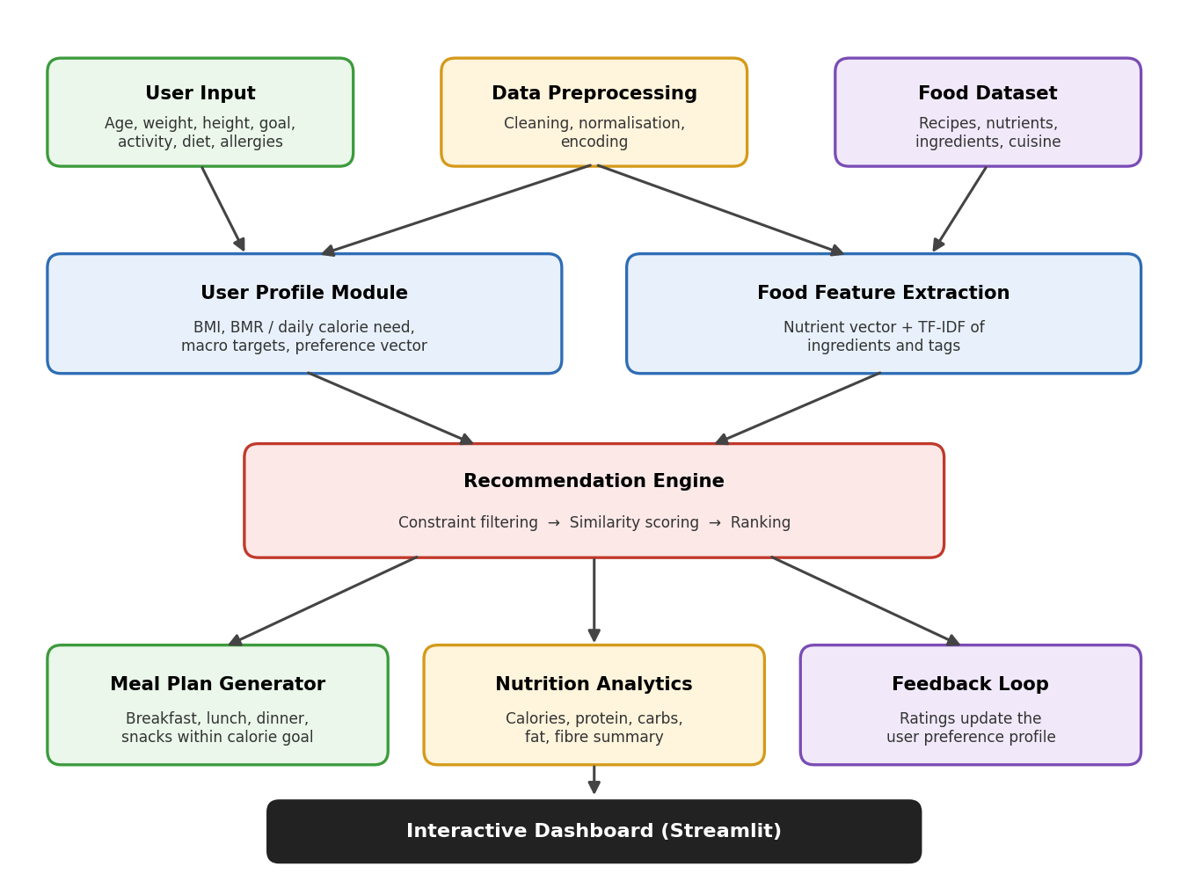
Fig. 3.1 Architecture diagram of AI-Based Food Recommendation System

3.4 Proposed System Workflow
The system follows a sequential workflow to generate recommendations. First, the user enters personal details, dietary preference, allergies and health goal. The input is validated and converted into a structured user profile.
The system calculates the BMI, daily calorie requirement and macronutrient targets. In parallel, the food dataset is cleaned and each food item is represented using nutrient values and text features from ingredients and tags. Foods that violate the allergy, diet or calorie constraints are filtered out.
The remaining foods are scored using cosine similarity against the user preference vector and ranked. The top-ranked foods are arranged into a daily meal plan for breakfast, lunch, dinner and snacks. Finally, the recommendations, meal plan and nutrition analytics are displayed on the dashboard, and the user’s ratings are saved as feedback.
Workflow:
User Input → Preprocessing → Profile Analysis → Feature Extraction → Constraint Filtering → Similarity Scoring and Ranking → Meal Plan and Analytics → Dashboard and Feedback
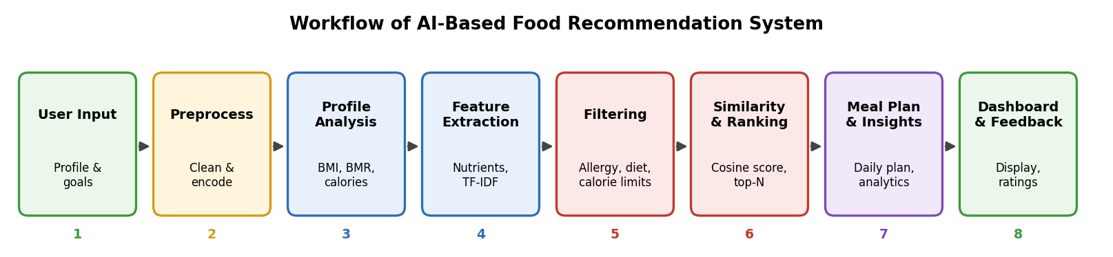
Fig. 3.2 Workflow of AI-Based Food Recommendation System

CHAPTER 4

MODULES DESCRIPTION

4.1 MODULE 1 – USER PROFILING AND NUTRITION ANALYSIS
The User Profiling and Nutrition Analysis module is responsible for understanding the user and calculating the nutritional requirement. The user enters details such as age, gender, height, weight, activity level, dietary preference (vegetarian, non-vegetarian or vegan), allergies and health goal (weight loss, maintenance or muscle gain).
The module validates the input and calculates the BMI, Basal Metabolic Rate, total daily calorie requirement and macronutrient targets. The calorie target is adjusted according to the selected goal. The result is stored as a structured user profile for the recommendation module.
Main Functions:
- User detail and preference input
- Input validation and preprocessing
- BMI calculation and weight-category identification
- BMR and daily calorie estimation
- Macronutrient target calculation
- Allergy and dietary-preference capture
- User profile creation
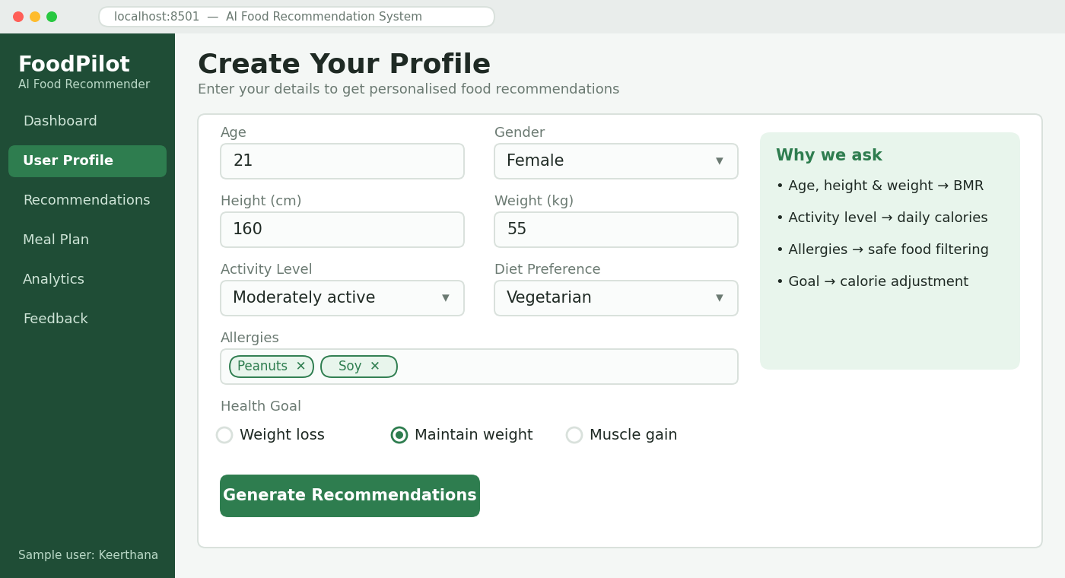
Fig. 4.1 User Profile Input Form
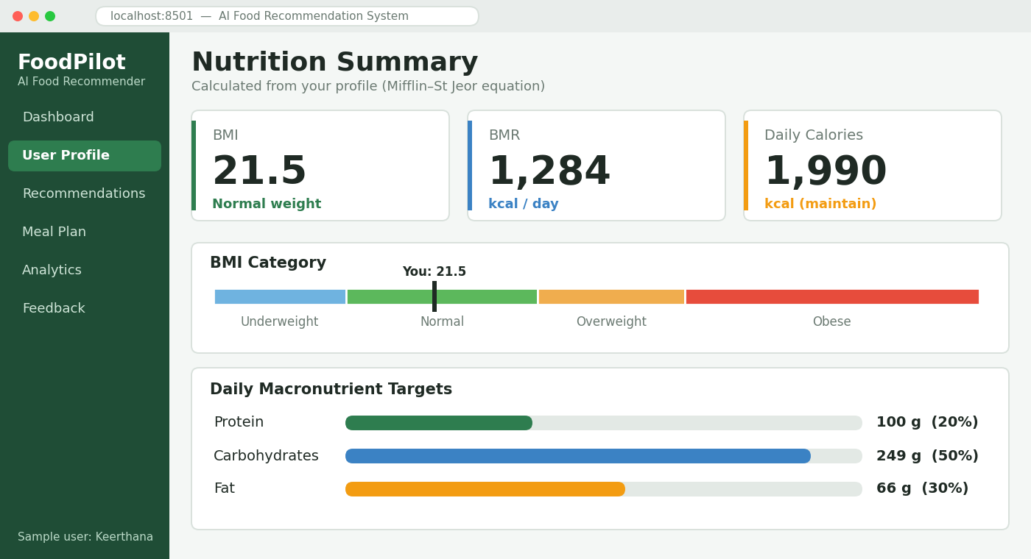
Fig. 4.2 Nutrition Summary (BMI, BMR and Calorie Target)

4.2 MODULE 2 – FOOD RECOMMENDATION AND MEAL PLANNING
The Food Recommendation and Meal Planning module uses the user profile generated by Module 1 to suggest suitable foods. Each food in the dataset is represented using nutritional values, ingredients, cuisine and meal-type features.
The module performs constraint filtering, similarity-based recommendation, ranking, daily meal-plan generation, nutrition analytics and feedback-based refinement. Foods containing allergens or not matching the diet type are removed first. The remaining foods are ranked by cosine similarity, and the best items are arranged into a meal plan within the calorie target.
Main Functions:
- Allergy and diet-based filtering
- Food feature vector creation
- Cosine-similarity-based recommendation
- Ranking of top-N foods
- Daily meal-plan generation
- Nutrition analytics and visualization
- User rating and feedback collection
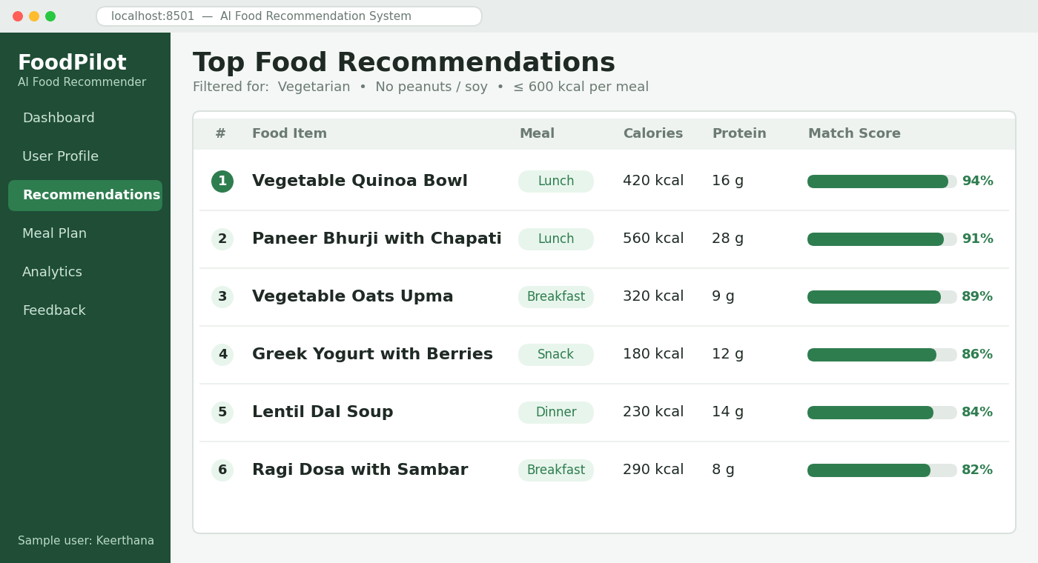
Fig. 4.3 Food Recommendation Results
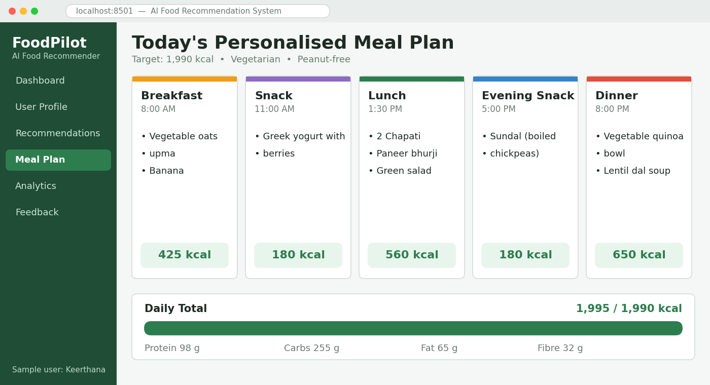
Fig. 4.4 Personalized Daily Meal Plan

CHAPTER 5

IMPLEMENTATION AND RESULTS

5.1 EXPERIMENTAL SETUP
The AI-Based Food Recommendation System was implemented as a Python-based application for estimating nutritional needs, recommending foods and generating meal plans. The system was tested using a sample food dataset containing nutritional values, ingredients and meal-type information, and sample user profiles. Each module was tested individually to verify its functionality and output.

5.1.1 Software and Technologies
Component | Technology
Programming Language | Python
Data Processing | Pandas, NumPy
Text Features | TF-IDF (Scikit-learn)
Recommendation Technique | Content-based filtering, Cosine similarity
Machine Learning Library | Scikit-learn
Visualization | Matplotlib / Plotly
User Interface | Streamlit
Database | SQLite
Development Environment | VS Code

5.1.2 Functional Testing
The major functions of the system were tested using sample inputs.
Test Case | Expected Output
User Profile Input | User details accepted and validated
BMI and Calorie Calculation | BMI and daily calorie target generated
Allergy Filtering | Foods containing selected allergens removed
Diet Preference Filtering | Only foods matching diet type retained
Food Recommendation | Ranked list of relevant foods displayed
Meal Plan Generation | Daily meal plan within calorie target generated
Nutrition Analytics | Calorie and nutrient summary displayed
Feedback Collection | User ratings stored successfully
Dashboard | Results displayed in a consolidated view

5.2 RESULTS
The implemented system provides an integrated interface for personalized food recommendation. The results include nutrition estimation, filtered food recommendations, a daily meal plan, nutrition analytics and feedback-based refinement.

5.2.1 Dashboard
The dashboard provides a centralized view of the user’s profile, nutrition targets, recommended foods and meal plan, and gives access to the different modules of the system.
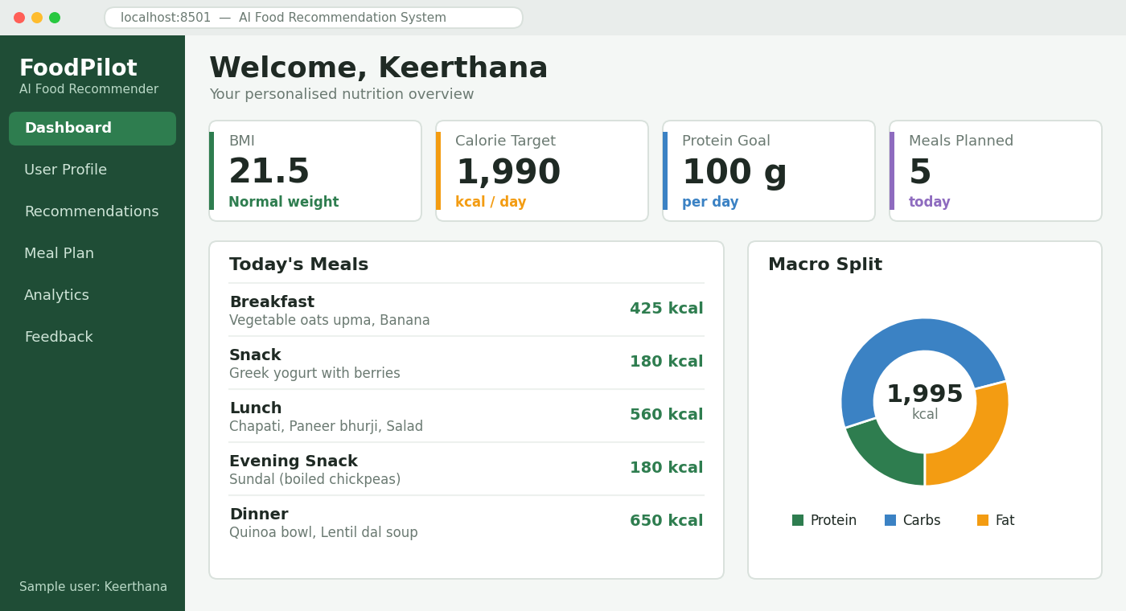
Fig. 5.1 Dashboard of AI-Based Food Recommendation System

5.2.2 User Profile and Nutrition Analysis
The profile module accepts the user details and displays the calculated BMI, daily calorie requirement and macronutrient targets. These values are used by the recommendation module.
Fig. 5.2 User Profile and Nutrition Analysis

5.2.3 Allergy and Diet Filtering
The system removes foods that contain the user’s allergens or do not match the selected diet type before recommendation, so that every suggested item is suitable for the user.
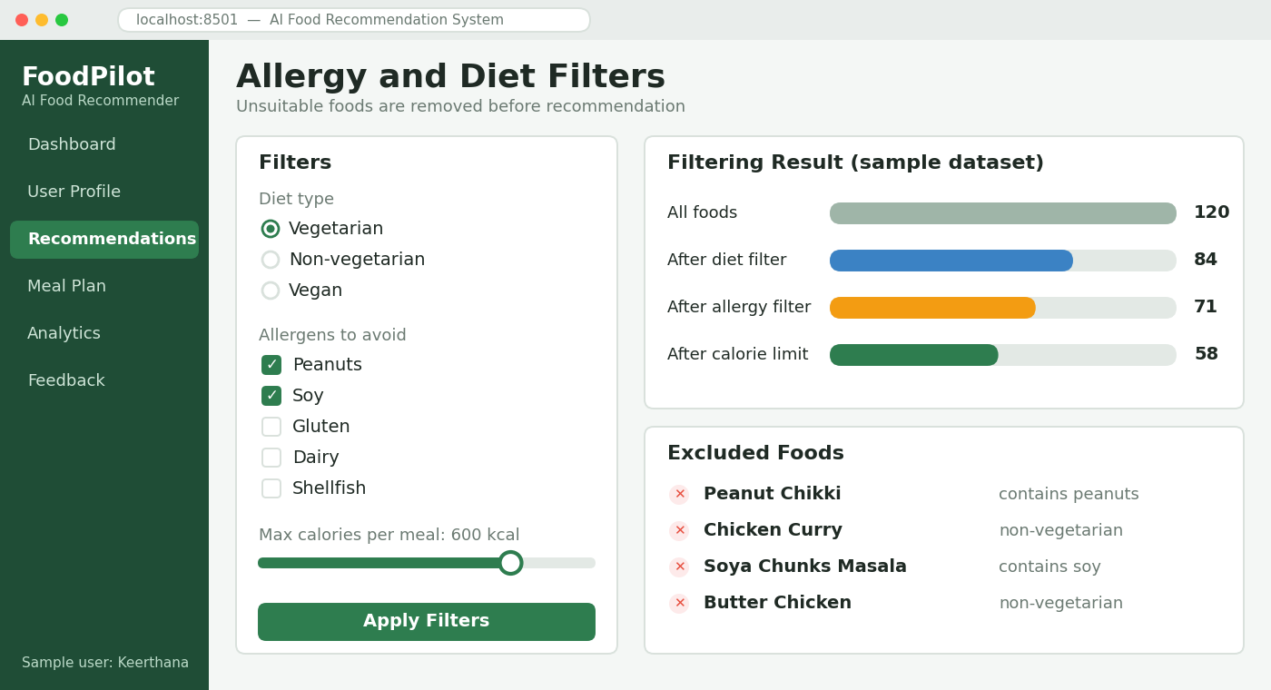
Fig. 5.3 Allergy and Diet Filters

5.2.4 Food Recommendation
The recommendation module compares the user preference vector with the features of the filtered foods and displays the most relevant items in ranked order.
Fig. 5.4 Food Recommendation Results

5.2.5 Daily Meal Plan
The meal-plan module arranges the recommended foods into breakfast, lunch, dinner and snacks so that the total energy stays close to the daily calorie target.
Fig. 5.5 Personalized Daily Meal Plan

5.2.6 Nutrition Analytics
The analytics component presents the calories, protein, carbohydrates, fat and fibre of the planned meals through charts, helping the user compare the plan with the targets.
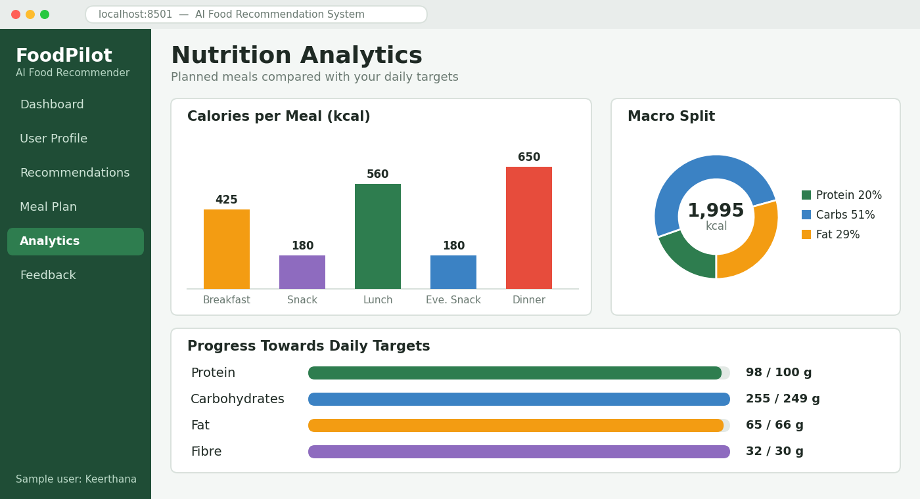
Fig. 5.6 Nutrition Analytics

5.2.7 User Feedback
Users can rate the recommended foods. The ratings are stored and used to adjust the preference profile, so that later recommendations become more personalized.
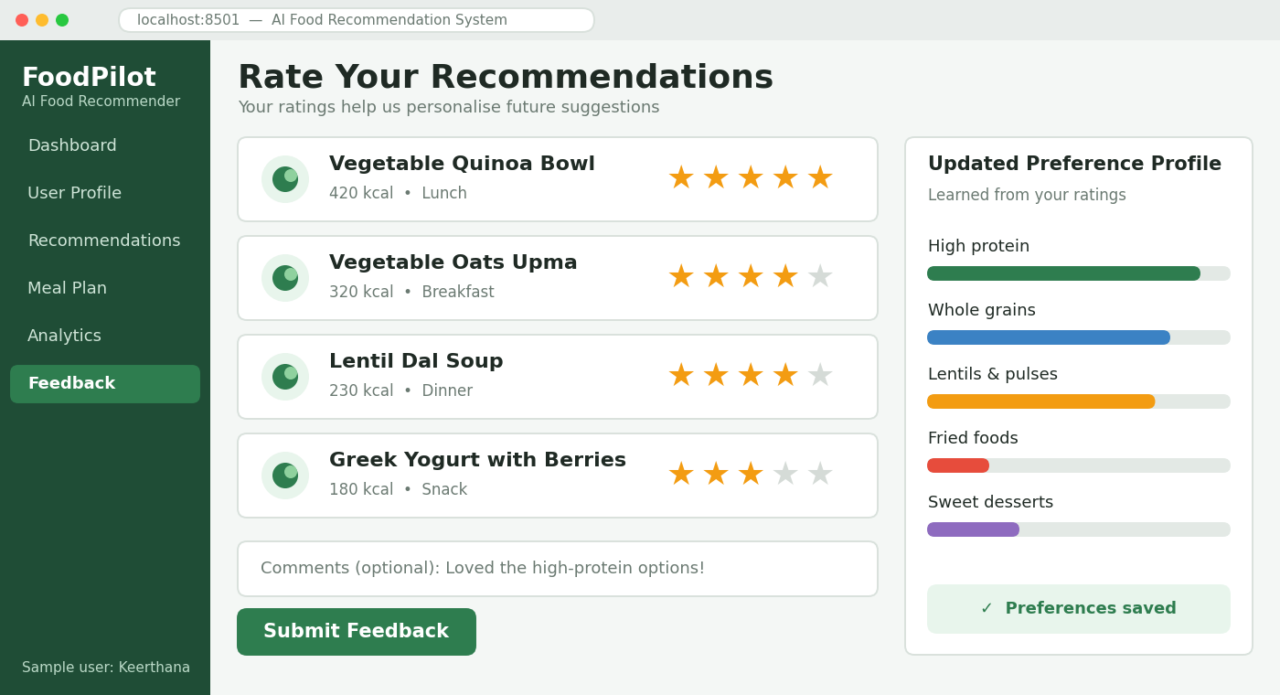
Fig. 5.7 User Feedback and Ratings

CHAPTER 6

CONCLUSION AND FUTURE WORK

6.1 Conclusion
The AI-Based Food Recommendation System is a personalized platform developed to help users choose suitable foods and plan healthy meals. The system integrates user profiling, calorie and nutrient estimation, allergy and diet-based filtering, similarity-based recommendation, meal-plan generation, nutrition analytics and feedback collection into a single application.
By combining data processing, content-based filtering and nutritional calculation, the system converts user information into meaningful food suggestions. It helps users understand their nutritional needs, avoid unsuitable foods and follow a balanced diet that matches their preferences and goals.
The modular design allows different features to be integrated within a common dashboard. The system therefore demonstrates how Artificial Intelligence can be applied to personalized nutrition and healthy-food decision making.

6.2 Future Work
The future development of the system can include:
- Integration of larger and regional food databases with verified nutrition data.
- Collaborative and hybrid filtering using ratings from many users.
- Image-based food recognition and automatic calorie estimation.
- Support for medical conditions such as diabetes and hypertension with expert validation.
- Integration with wearable devices for activity and health tracking.
- Grocery list generation and recipe cooking guidance.
- Explainable recommendations showing why a food was suggested.
- Multilingual and voice-based assistance.
- Progress tracking of weight and nutrition goals over time.
- Secure cloud-based storage of user profiles and history.

CHAPTER 7

REFERENCES
- Ricci, F., Rokach, L. and Shapira, B. (Eds.) (2022), Recommender Systems Handbook, 3rd ed., Springer.
- Aggarwal, C. C. (2016), Recommender Systems: The Textbook, Springer.
- Trattner, C. and Elsweiler, D. (2017), “Food Recommender Systems: Important Contributions, Challenges and Future Research Directions,” arXiv preprint arXiv:1711.02760.
- Min, W., Jiang, S. and Jain, R. (2019), “A Survey on Food Computing,” ACM Computing Surveys, Vol. 52, No. 5.
- Mifflin, M. D. et al. (1990), “A new predictive equation for resting energy expenditure in healthy individuals,” The American Journal of Clinical Nutrition, Vol. 51, No. 2, pp. 241–247.
- Manning, C. D., Raghavan, P. and Schütze, H. (2008), Introduction to Information Retrieval, Cambridge University Press.
- Bishop, C. M. (2006), Pattern Recognition and Machine Learning, Springer.
- Pedregosa, F. et al. (2011), “Scikit-learn: Machine Learning in Python,” Journal of Machine Learning Research, Vol. 12, pp. 2825–2830.
- Python Software Foundation, Python Documentation.
- Streamlit, Streamlit Documentation.
- SQLite, SQLite Documentation.

